## 2.3.3 Build Screen

### 2.3.3.1 Purpose

* This view is where all of the information for the selected build is housed.
* The information laid out on this view includes:
  + Character/Role
  + Rune Selection
  + Summoner selector
  + Start items
  + Start skill
  + Skill priority
  + Skill order
  + Item tree list
* All decisions pertaining to this view was made prior to arriving to the view.
* This view brings the user closer to accomplishing their goal by providing the information needed for a desired build.
* Users can get access to this view from the build list screen
* From this view, users can either go back to the previous view (build list) or access the hamburger overlay to go to one of the views listed under it.

### 2.3.3.2 Wireframe Screenshot

### 2.3.3.3 Mockup Screenshot

### The Android images represent possible pictures that will be inserted later

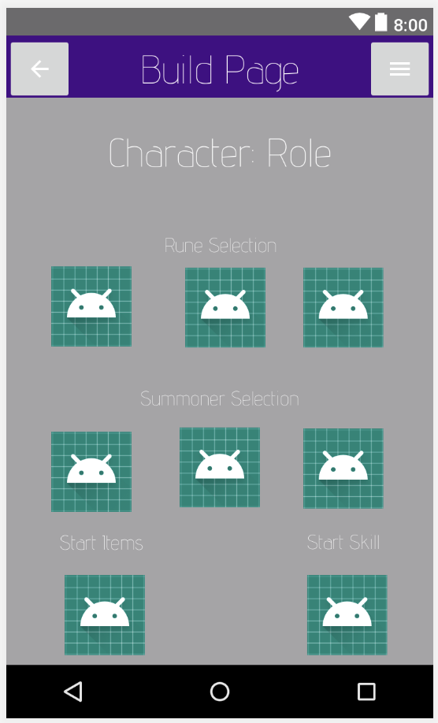

### 2.3.3.4 Prototype Screenshot Screenshot of prototype for this interface goes here.

### 2.3.3.5 Design Commentary

Talk about how your UI changed as it went through the steps of Wireframe -> Mockup -> Prototype. What did you like / dislike at each stage that influenced the next round of UI development?